“Fascinating. Beautifully written. Deeply researched. With sensitivity and respect, Wendy Call has written about the modernization of a centuries-old community. It’s a story happening everywhere, including our own backyard. This is a book written with humility, bravery, and wisdom, and honors those who trusted the writer with their incredible stories.” —Sandra Cisneros

No Word for Welcome: The Mexican Village Faces the Global Economy
No Word for Welcome (University of Nebraska Press, 2011) explores the intersection of village life and the global economy. In awarding No Word for Welcome the 2011 Grub Street National Book Prize for Nonfiction, judge Michelle Seaton noted that the book “cuts through the rhetoric of globalization to show what happens to a community when the government, abetted by international industrial interests, threatens to build a superhighway through farmland and to turn ancient fishing waters into shrimp farms, ostensibly for the good of all. Author Wendy Call shows the effects of industrialization not by preaching against it or by romanticizing village life from afar; instead she introduces us to the people she came to know while living for two years on the Isthmus of Tehuantepec, in Mexico’s extreme south, often called the country’s “little waist.” In beautiful prose, she profiles a teacher, a fisherman and several activists in the region in order to show how even the threat of change can divide a community.”
Publishers Weekly says of Call’s work: “[S]he writes lively narrative, detailed description, and engaging scenes.” The Iowa Review writes: “Call’s graceful movement between cultures demonstrates her considerable skills as a writer, and especially as a translator. . . . Wendy Call's book is at once a portrait…and a warning to the rest of the citizens of our global village.”
Educational institutions including Oberlin College, SUNY, University of Pittsburgh and Yakima Valley Community College featured Call in their 2011 Visiting Writer Series. In 2012, she will be part of similar series at Grub Street in Boston, Pacific Lutheran University and University of Wisconsin / Oshkosh. She will also be a featured presenter at the Chuckanut Writers Conference, Eastern Washington’s Get Lit! Festival, Split This Rock Poetry Festival, and the Virginia Festival of the Book.
During Wendy Call’s five-month book tour in 2011, she traveled from the Atlantic to the Pacific Oceans—just like the old railroad system she writes about in No Word for Welcome. She spoke about the book at forty literary, university, and community venues, and gave more than thirty interviews (in English and Spanish) with commercial, public and community radio networks.
page one of two

No Word for Welcome, page two of two

• In June and July Wendy Call traveled the West Coast, with a dozen interviews and appearances, including a week on the faculty of the Port Townsend Writers’ Conference.
• In August and September she served as 2011 Artist in Residence at Vermont’s Marsh-Billings-Rockefeller National Historical Park, exploring the relationships between our national parks, national identity, and ecological restoration. Her residency was supported by Maine’s K2 Family Foundation and Washington State’s 4Culture. It included twenty readings, lectures, slideshows and workshops throughout New England and the Mid-Atlantic on the subjects of globalization, sustainability, and storytelling.
• October took her to Iowa, to serve as Distinguished Visiting Writer at Cornell College in Mount Vernon. While in the Midwest she will gave readings and presentations in Chicago, Iowa City, Milwaukee, and Minneapolis. She was also a featured presenter at the Texas and Wisconsin Book Festivals.
• Call crossed the border in November, offering presentaciones del libro in the Isthmus of Tehuantepec, Mexico. She also coordinated a gathering for Mexican women authors working in indigenous languages, made possible by the Macondo Foundation and the National Association of Latino Arts and Culture (NALAC).
In many cities, Call’s events were made possible by collaborations with grassroots organizations, including CHICLE in Chapel Hill, Encuentro 5 in Boston, Guild Literary Complex in Chicago, Institute for Policy Studies in Washington DC, International Development Exchange (IDEX) in San Francisco, La Sala and One Equal Heart in Seattle, and the Casa de la Cultura and UCIZONI—featured in No Word for Welcome—in southern Mexico.

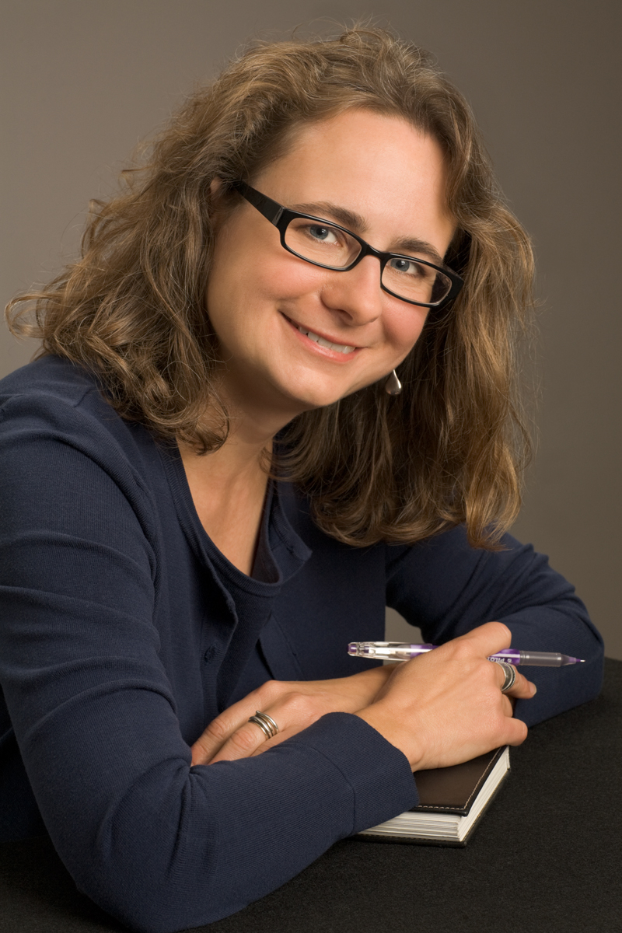
Wendy Call is a recent writer-in-residence at Harborview Medical Center, New College of Florida and Seattle University. She is co-editor of Telling True Stories: A Nonfiction Writers’ Guide (Penguin, 2007). She holds a BA in biology from Oberlin College and an MFA in creative writing from Bennington College. Prior to 2000, Call devoted a decade to work for social change organizations in Boston and in Seattle, her current home.

