Christopher Columbus

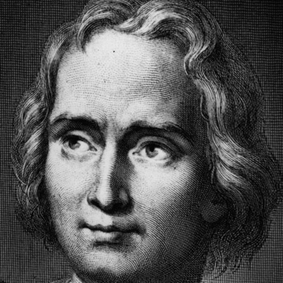

Explorer and navigator Christopher Columbus was born in 1451 in the Republic of Genoa, Italy.

His first voyage into the Atlantic Ocean in 1476 nearly cost him his life.

Columbus participated in several other expeditions to Africa.

1492, Columbus left Spain in the Santa Maria, with the Pinta and the Niña along side.

First Voyage to the New World
Rejected by the Portuguese king for a three-ship voyage of discovery, Columbus took his plan first to Genoa and then to Venice but was rejected there too. He then went to the Spanish monarchy of Isabella of Castille and Ferdinand of Aragon, in 1486. Their nautical experts too were skeptical and initially, Columbus was rejected. The idea however, must have intrigued the monarchs, for they kept Columbus on a retainer. But their focus was on a war with the Muslims and Columbus would have to wait.
Columbus continued to lobby the royal court and soon after the Spanish army captured the last Muslim stronghold in Granada in January of 1492, the monarchs agreed to finance his expedition. In August of 1492, Columbus left Spain in the Santa Maria, with the Pinta and the Niña along side.
After 36 days of sailing, Columbus and several crewmen set foot on an island in the present day Bahamas, claiming it for Spain. There he encountered a timid but friendly group of natives who were open to trade with the sailors exchanging glass beads, cotton balls, parrots and spears. The Europeans also noticed bits of gold the natives wore for adornment.
Columbus and his men continued their journey, visiting the islands of Cuba and Hispaniola (now Haiti and the Dominican Republic) and meeting with the leaders of the native population. During this time, the Santa Maria was wrecked on a reef off the coast of Hispaniola. With the help of some islanders, Columbus' men salvaged what they could and built the settlement Villa de la Navidad ("Christmas Town") with lumber from the ship. Thirty-nine men stayed behind to occupy the settlement. Convinced his exploration had reached Asia, he set sail for home with the two remaining ships.
Second Voyage
Returning to Spain in 1493, Columbus gave a glowing, somewhat exaggerated report and was warmly received by the royal court. That same year he took to the seas on his second expedition and explored more islands in the Caribbean Ocean. Upon arrival at Hispaniola, Columbus and his crew discovered the Navidad settlement had been destroyed with all the sailors massacred. Spurning the wishes of the queen, who found slavery offensive, Columbus established a forced labor policy over the native population to rebuild the settlement and explore for gold, believing it would prove to be profitable. His efforts produced small amounts of gold and great hatred among the native population. Before returning to Spain, Columbus left his brothers Bartholomew and Diego to govern the settlement on Hispaniola and sailed briefly around the larger Caribbean islands further convincing himself he had discovered the outer islands of China.
Third Voyage
It wasn't until his third voyage that Columbus actually reached the mainland exploring the Orinoco River in present-day Venezuela. In this voyage, he believes, he found the Earthly Paradise.
Unfortunately, conditions at the Hispaniola settlement had deteriorated to the point of near-mutiny with settlers claiming they had been misled by Columbus' claims of riches and complaining about the poor management of his brothers. The Spanish Crown sent a royal official who arrested Columbus and stripped him of his authority. He returned to Spain in chains to face the royal court. The charges were later dropped but Columbus lost his titles as governor of the Indies and for a time, much of the riches made during his voyages.
Fourth Voyage
Convincing King Ferdinand that one more voyage would bring the abundant riches promised, Columbus went on what would be his last voyage in 1502, traveling along the eastern coast of Central America in an unsuccessful search for a route to the Indian Ocean. A storm wrecked one of his ships stranding the captain and his sailors on the island of Cuba. During this time, local islanders, tired of the Spaniards poor treatment and obsession with gold, refused to give them food.
In a spark of inspiration, Columbus consulted an almanac and devised a plan to "punish" the islanders by taking away the moon. On February 29, 1504, a lunar eclipse alarmed the natives enough to re-established trade with the Spaniards. A rescue party finally arrived, sent by the royal governor of Hispaniola in July and Columbus and his men were taken back to Spain in November of 1504.
Last Days
In the two remaining years of his life, Columbus struggled to recover his lost titles and in May of 1505 did regain some of his riches, but his titles were never returned. He died May 20, 1506 still believing he had discovered a shorter route to Asia.

