Amerigo Vespucci
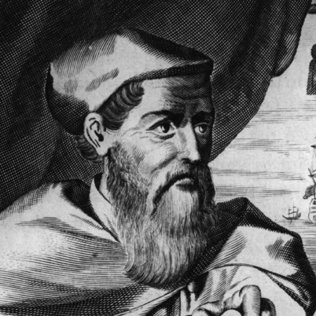

Navigator and explorer Amerigo or Americo Vespucci, the third son in a cultured family, was born on March 9, 1451, in Florence, Italy. Although born in Italy, Vespucci became a naturalized citizen of Spain in 1505.

While his older brothers headed off to the University of Pisa in Tuscany, Vespucci received his early education from his paternal uncle, a Dominican friar named Giorgio Antonio Vespucci.

Guido Antonio Vespucci, who was ambassador of Florence under King Louis XI of France, sent his nephew on a brief diplomatic mission to Paris. The trip likely awakened Vespucci's fascination with travel and exploration.

In the late 1490s, Vespucci became affiliated with merchants who supplied Christopher Columbus on his later voyages.

In 1496, after Columbus returned from his voyage to America, Vespucci had the opportunity to meet him in Seville.

By the late 1490s, Vespucci's business was struggling to make a profit. Vespucci knew that King Ferdinand and Queen Isabella of Spain were willing to fund subsequent voyages by other explorers. Then in his 40s, Vespucci, enticed by the prospect of fame, decided to leave his business behind and become an explorer.

It is not proven but it seems that Vespucci discovered Venezuela a year before Christopher Columbus did. Vespucci and his fleets arrived back in Cadiz in October 1498.

In May of 1499, sailing under the Spanish flag, Vespucci embarked on his next expedition, as a navigator under the command of Alonzo de Ojeda. Crossing the equator, they traveled to the coast of what is now Guyana, where it is believed that Vespucci left Ojeda and went on to explore the coast of Brazil. During this journey Vespucci is said to have discovered the Amazon River and Cape St. Augustine.

On May 14, 1501, Vespucci departed on another trans-Atlantic journey. Now on his third voyage, Vespucci set sail for Cape Verde—this time in service to King Manuel I of Portugal.

In 1507, some scholars at Saint-Dié-des-Vosges in northern France were working on a geography book called Cosmographiæ Introductio, which contained large cut-out maps that the reader could use to create his or her own globes. German cartographer Martin Waldseemüler, one of the book's authors, proposed that the newly discovered Brazilian portion of the New World be labeled America, the feminine version of the name Amerigo, after Amerigo Vespucci. The gesture was his means of honoring the person who discovered it, and indeed granted Vespucci the legacy of being America's namesake.

In 1505, Vespucci, who was born and raised in Italy, became a naturalized citizen of Spain. Three years later, he was awarded the office of piloto mayor, or master navigator, of Spain. In this role, Vespucci's job was to recruit and train other navigators, as well as to gather data on continued New World exploration. Vespucci held the position for the remainder of his life.
On February 22, 1512, Amerigo Vespucci died of malaria in Seville, Spain. He was just a month shy of 58 years old.

